|  |
| --- |
|  |
| **SmartAttend** |



**Cloud Computing Project Proposal**

Team Members, Class ID:

Chakra Pavan Kumar Kota,

Dharani Muli.

**1. TITLE:** SmartAttend

# **Motivation**

We got motivated by observing below some of the concerns faced by students and instructors.

1. For instructor its time taking to capture attendance manually in every class and observe each individual performance and interest on subject.
2. For a student it’s very difficult to collaborate with everyone in class and know each other, sharing their knowledge.

# **3. Objective**

1. To bring ease in tracking the attendance for instructors.
2. To provide a solution that helps students collaborate, interact with each other with ease considering the privacy aspects.

**Systems Features:**

* + 1. **Priority 1:**
       1. Attendance barcode scanner
       2. Analytics on Attendance report
       3. User Authentication
       4. Cross platform
    2. **Priority 2:**
       1. Group chat with respect to course
       2. Add user to group
       3. Remove user from group
       4. Add files (attachments, videos)
       5. Individual chat
       6. Create small groups

# **4. Tools, languages and platforms**

1. Ionic
2. Firebase, Cassandra
3. Html5, CSS3
4. Angular
5. Azure
6. Node.js

# **5. Type of project:** Development

**6. Block Dragram:**

**Attendance report Module**

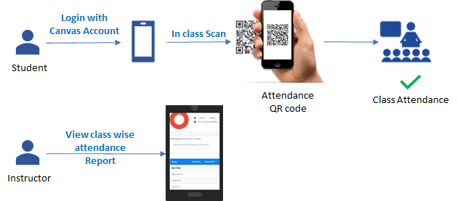

**Class Chat Module:**

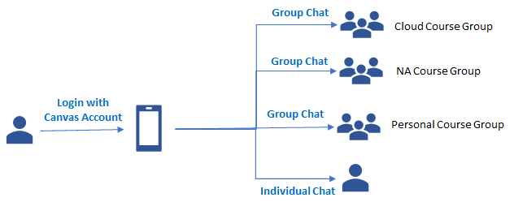

**7. Role of team members:**

* Research – Pavan (owner), Dharani
* Documentation – Pavan, Dharani (owner)
* Development – Pavan (owner), Dharani
* Project Management – Pavan, Dharani (owner)
* Performance Evaluation: Pavan, Dharani (owner)

**8. Deployment plan**

Iteration 1:

* Web Interface Development – Phase 1
* Design the system architecture, DB architecture
* Ends with a follow up meeting with Professor to show the progress and get feedback.

Iteration 2:

* Web Interface Development – Phase 2.
* Deploy product into Azure with complete testing.
* A follow up meeting with Professor to show the progress and get feedback.

Iteration 3:

* Bug fixes.
* A follow up meeting with Professor to show the progress and get feedback.

Final iteration:

* Final release with integrations and bug fixes.
* Final project presentation and document the project details.

**9. Expected project poutcome**

1. Build a real time application where in UMKC students and instructors use our application for collaboration, in class attendance maintenance and retrieve analytics on student’s class presence.
2. Should be compatible.
3. Should be cross platform.

**10. Individual learning outcome**

Chakra Pavan Kumar, Kota:

1. By end of the project I would like to have hands-on experience on mentioned software tools.
2. Explore the functionalities of cloud Azure by deploying app services.
3. I will learn and collaborate efficiently as an individual, as a team.

Dharani, Muli:

1. From this project I would like to get hands on experience on different tools and technologies like Ionic, firebase, Cassandra and Azure cloud technology.
2. Also gain knowledge of the best coding standards.
3. I will improve my collaboration skills working in a team.